1. Button Input

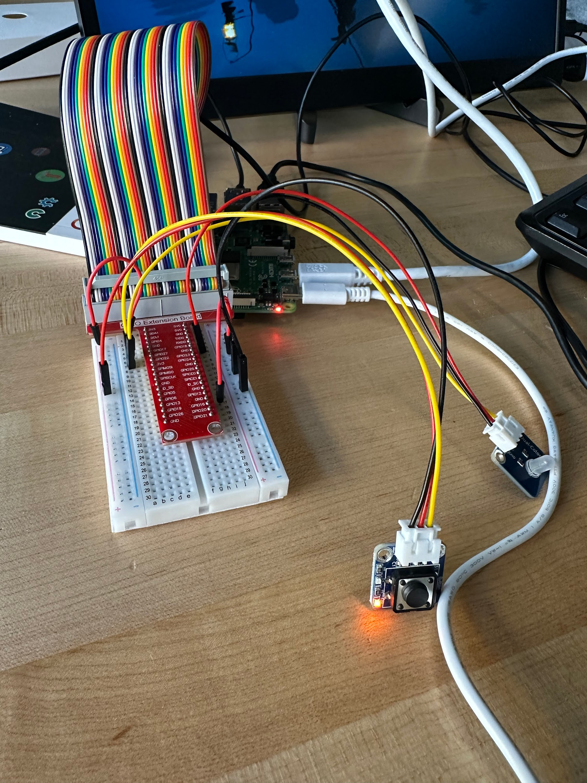

Video: <https://drive.google.com/file/d/1TQogC_e99FTKShUIV7kruZYFPGsq8XFQ/view?usp=drivesdk>

1. Buzzer Output

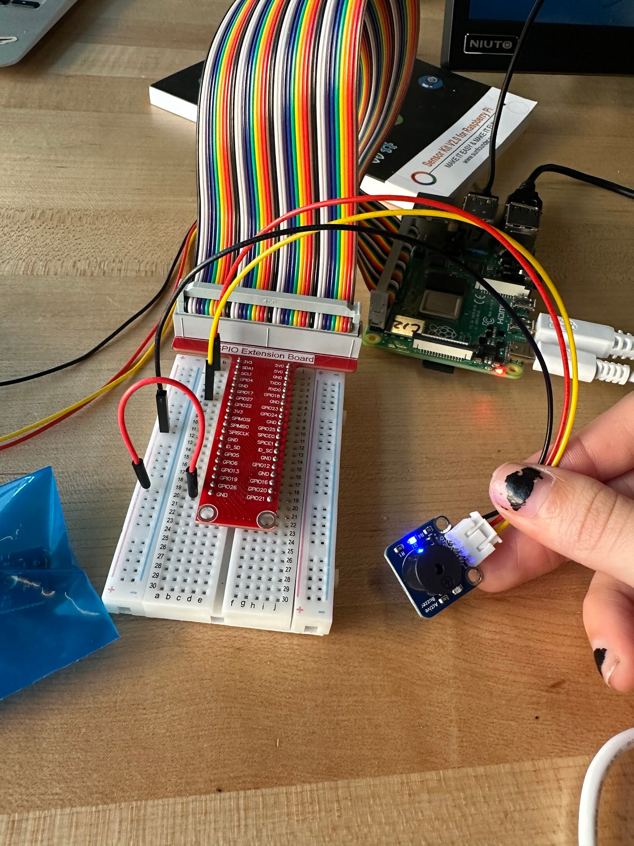

Active Video: <https://drive.google.com/file/d/11gbbSjs8ve7j0EJ4RH2inSu5Gt0BtJiK/view?usp=drivesdk>

Passive Video:

<https://drive.google.com/file/d/1rywDy9gSQPeJPz0f_9QIPu01MBl2p659/view?usp=drivesdk>

1. Vibrator Motor Output

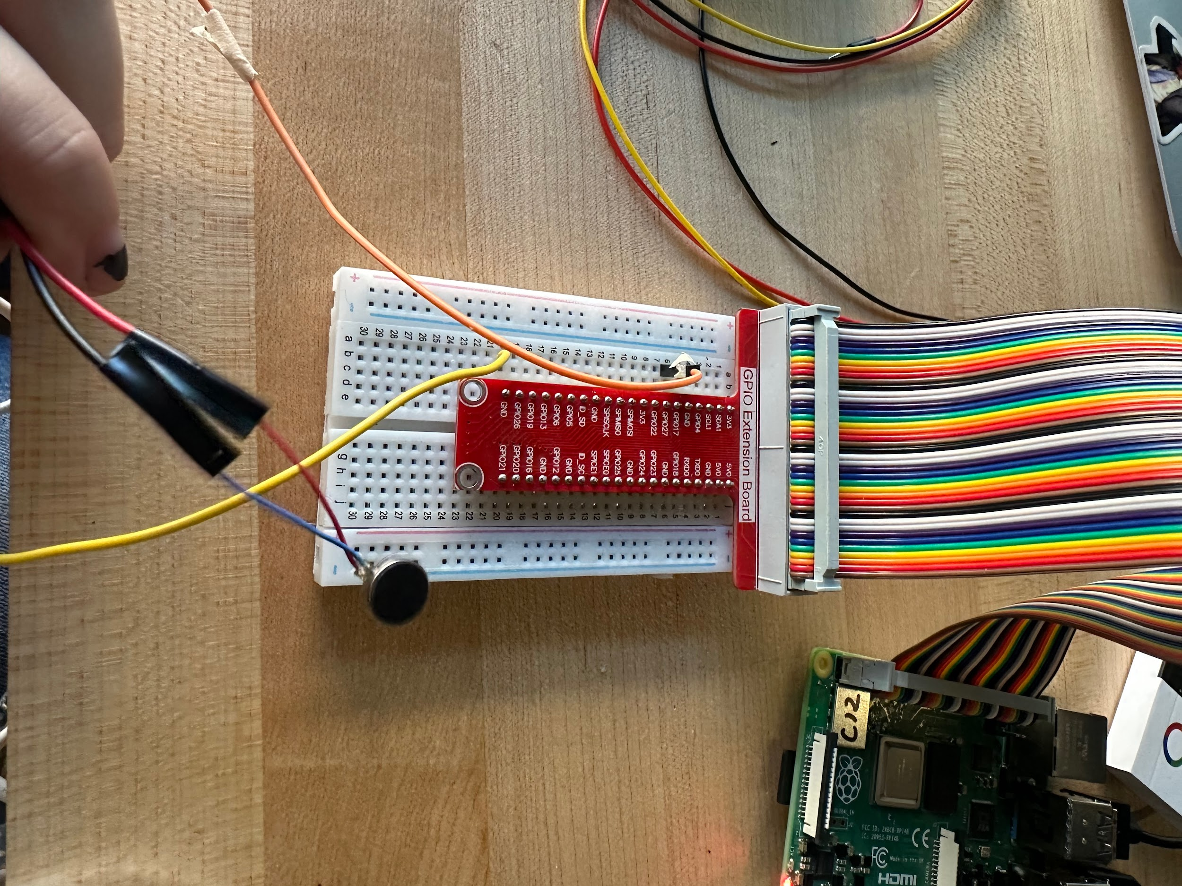

Video: <https://drive.google.com/file/d/1443bN9P_PsSyvK-glGK6mke65_PxVLUa/view?usp=drivesdk>

1. Sound Input

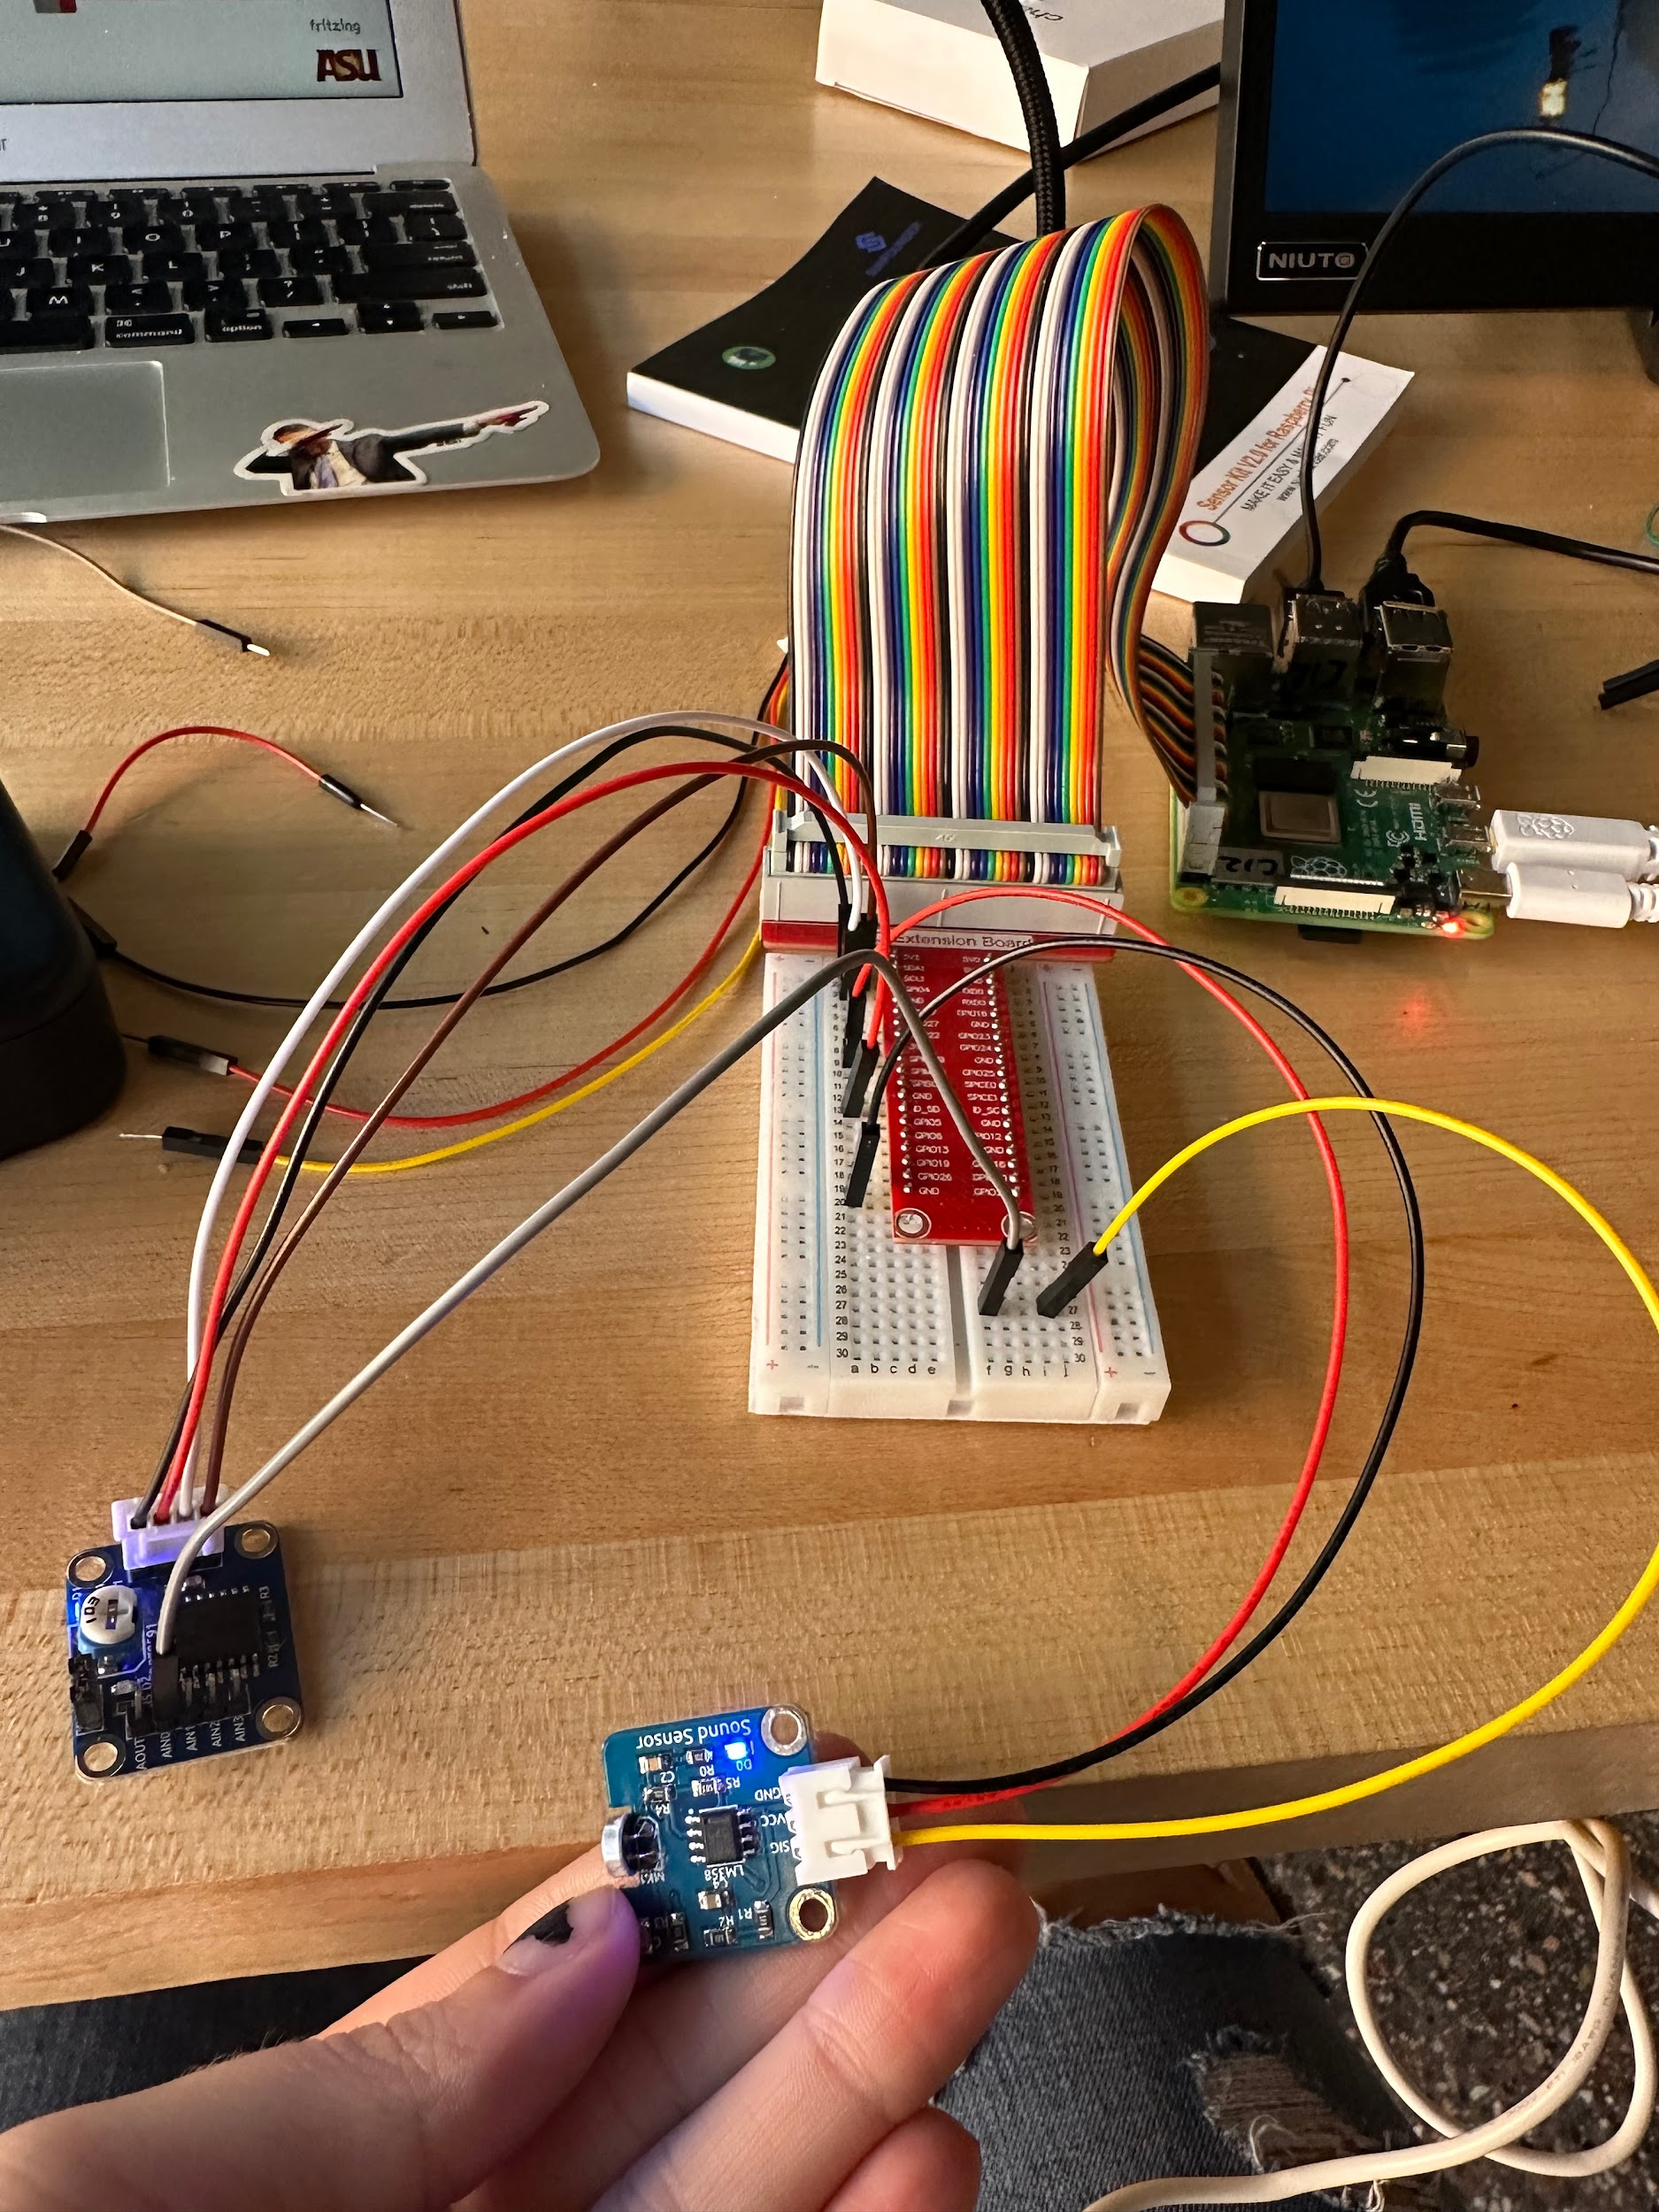

Video:

<https://drive.google.com/file/d/1fgE-eGXvAbo-yjC1BMuXow0_HZ3Bz4qB/view?usp=drivesdk>

1. Ultrasonic Sensor Input

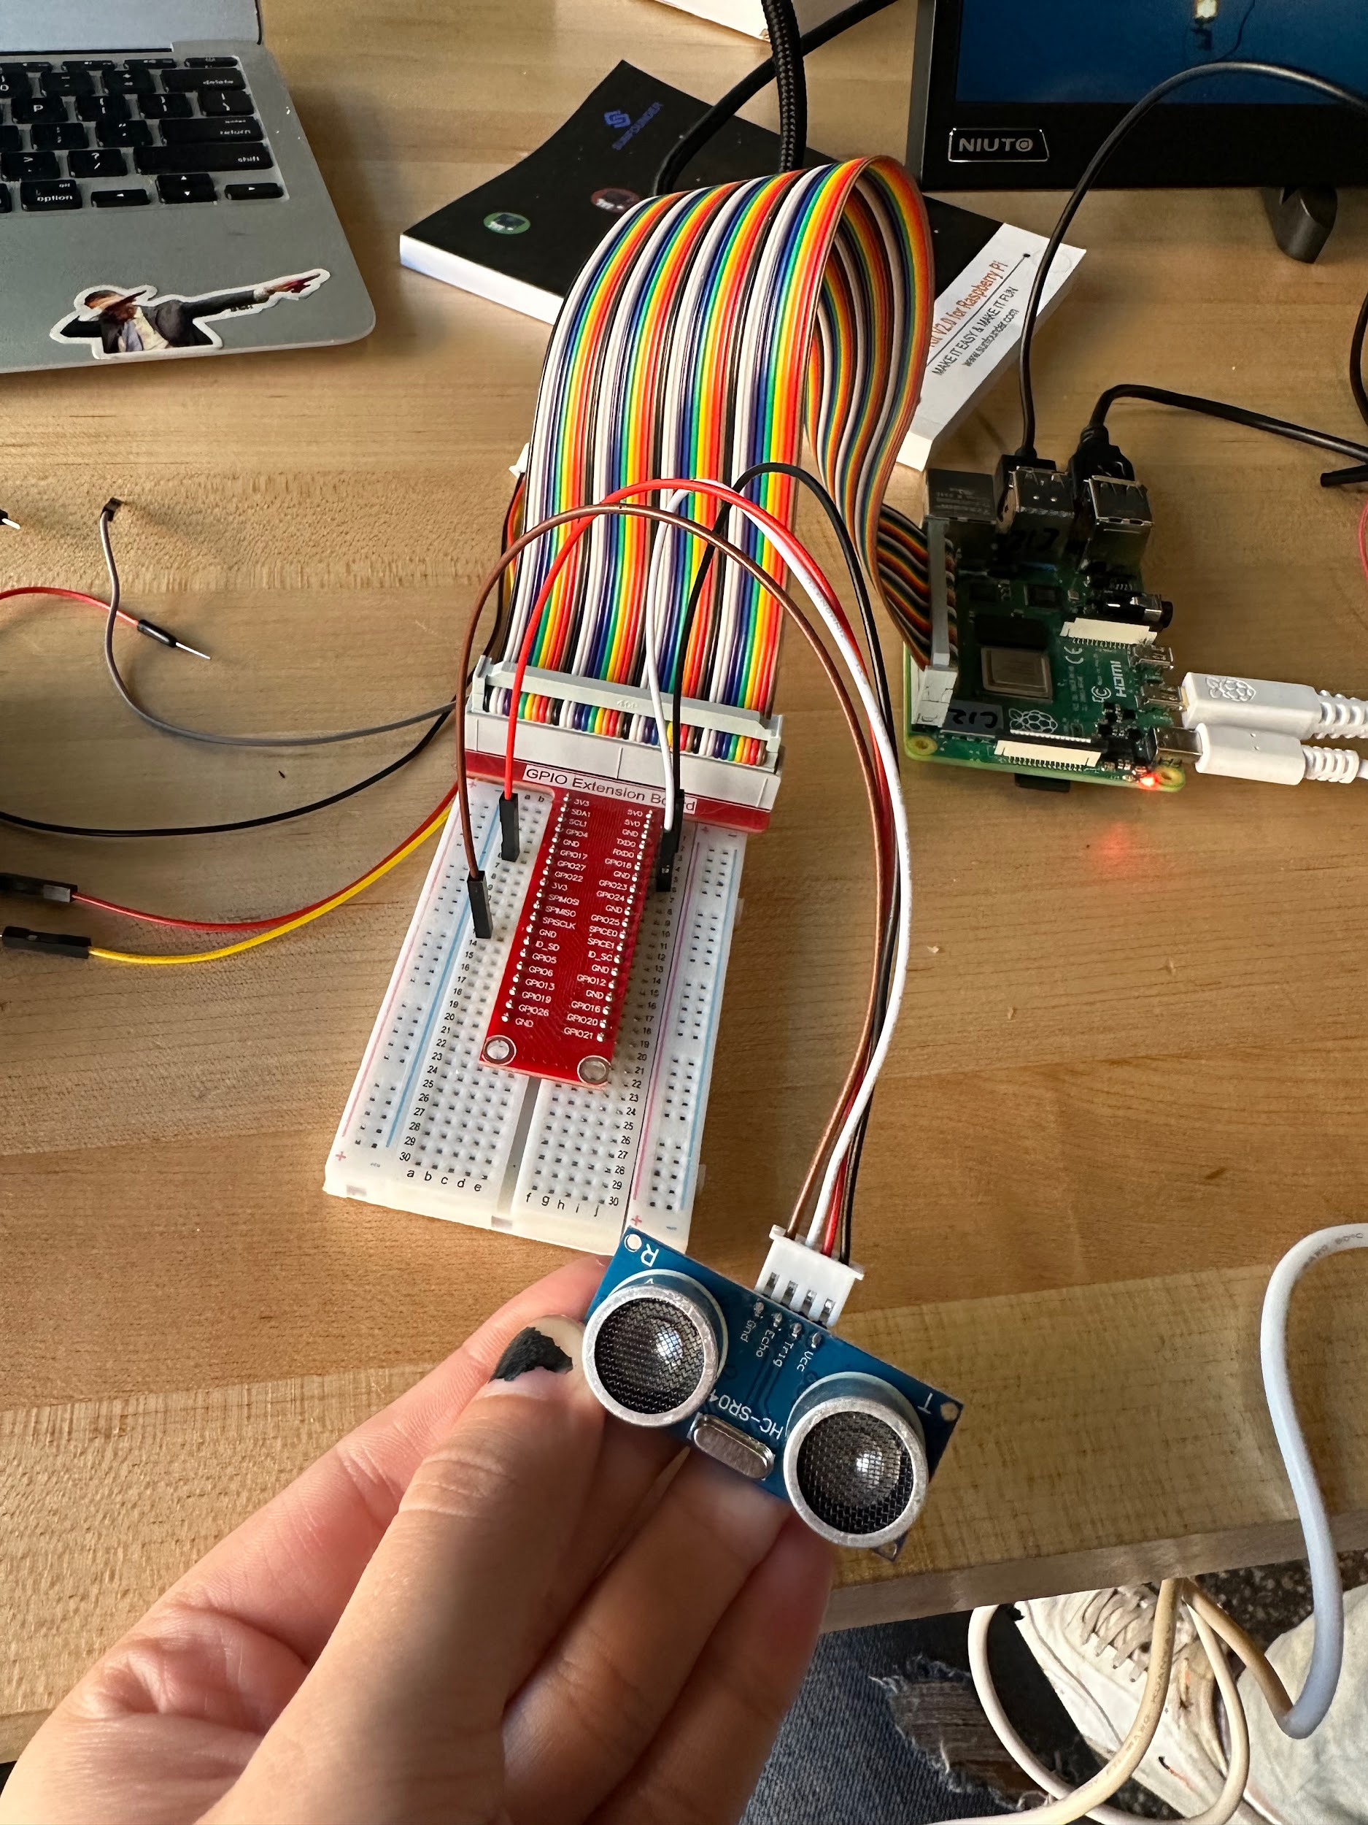

Video: <https://drive.google.com/file/d/1G9tXnc98srBeo3rpBNIKC88Y9QZaNKGZ/view?usp=drivesdk>

1. Touch Switch Input

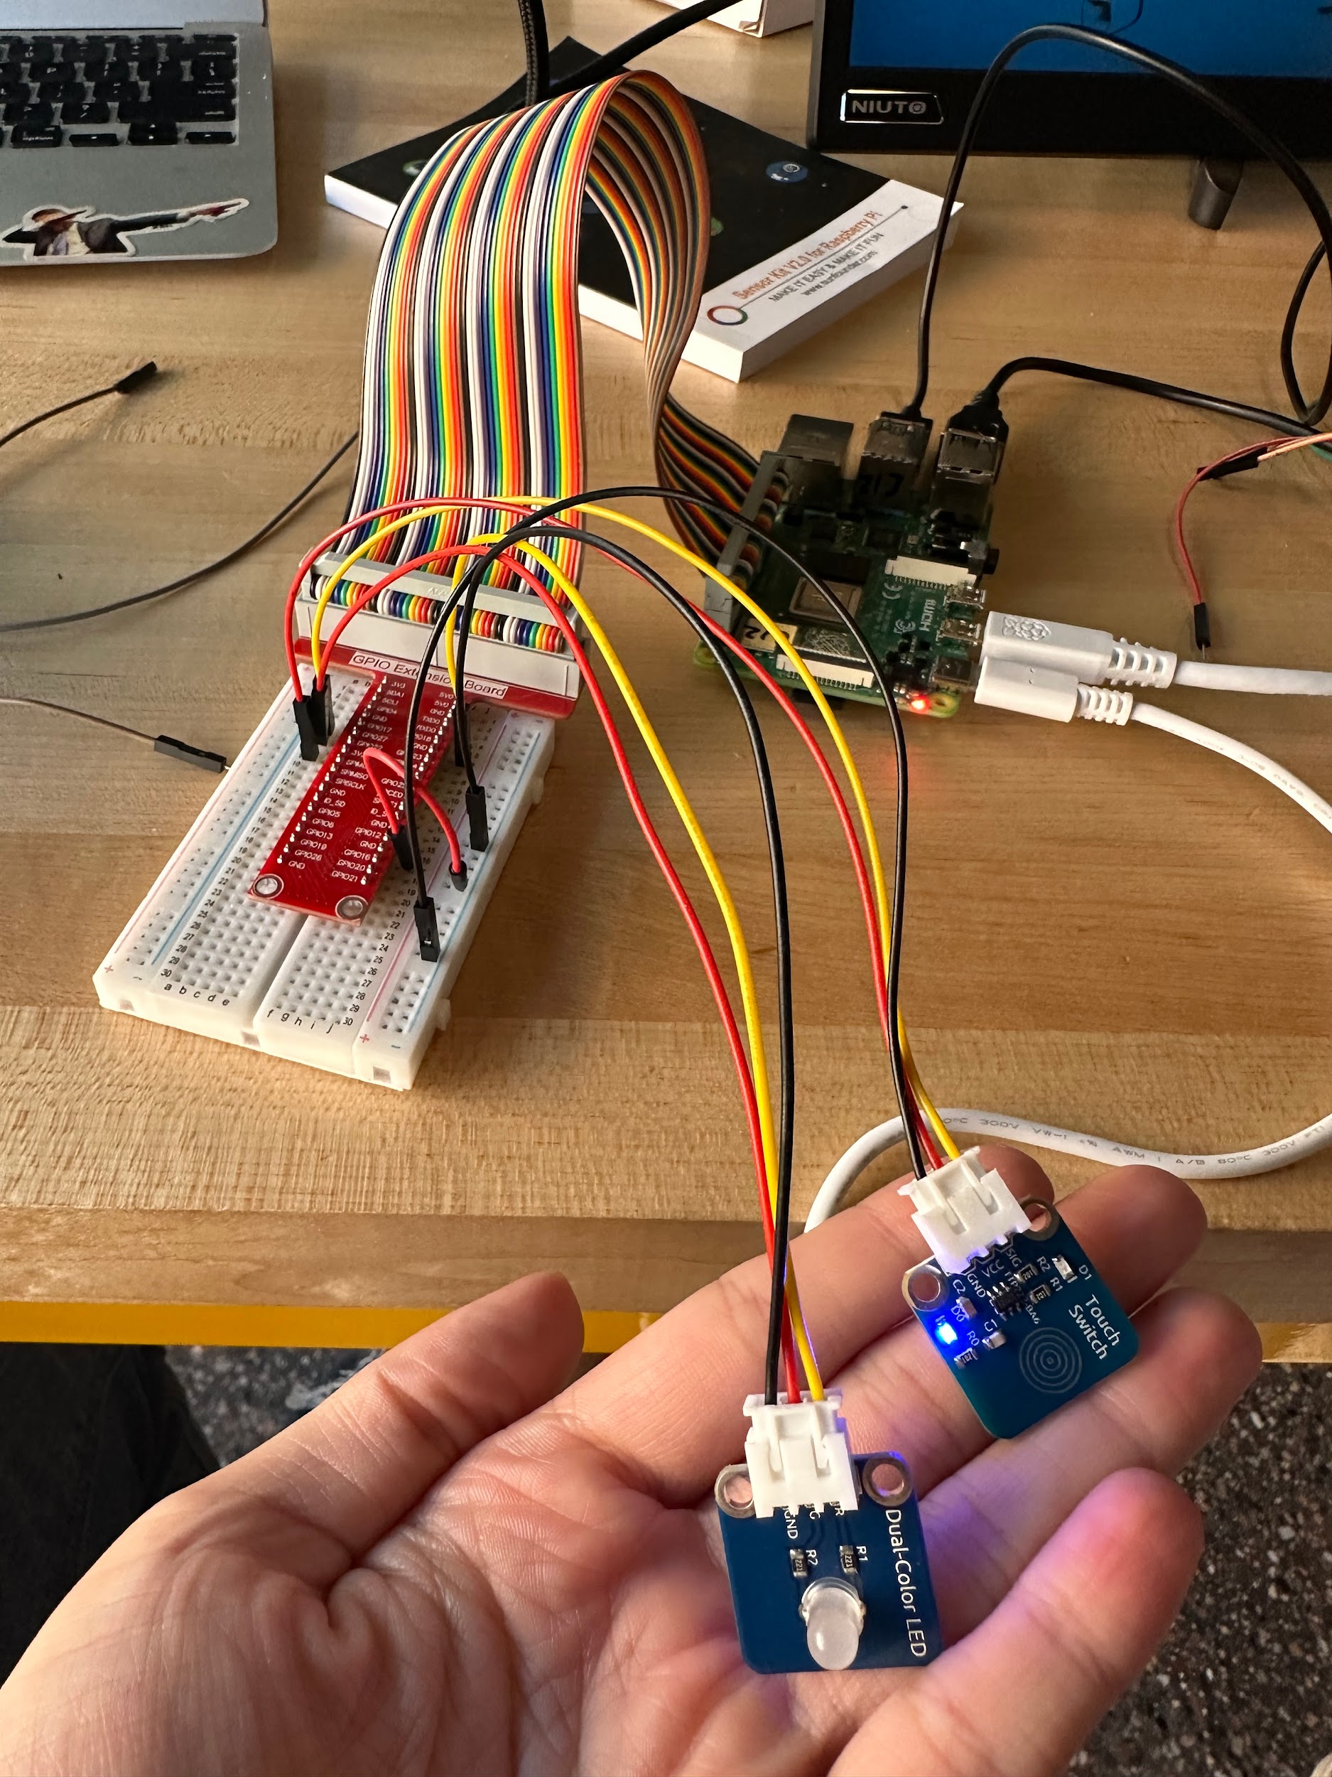

Video: <https://drive.google.com/file/d/17YOsq8nduML4kMhr1rjsuLdGSarMFnJL/view?usp=drivesdk>

1. Tracking Sensor Input

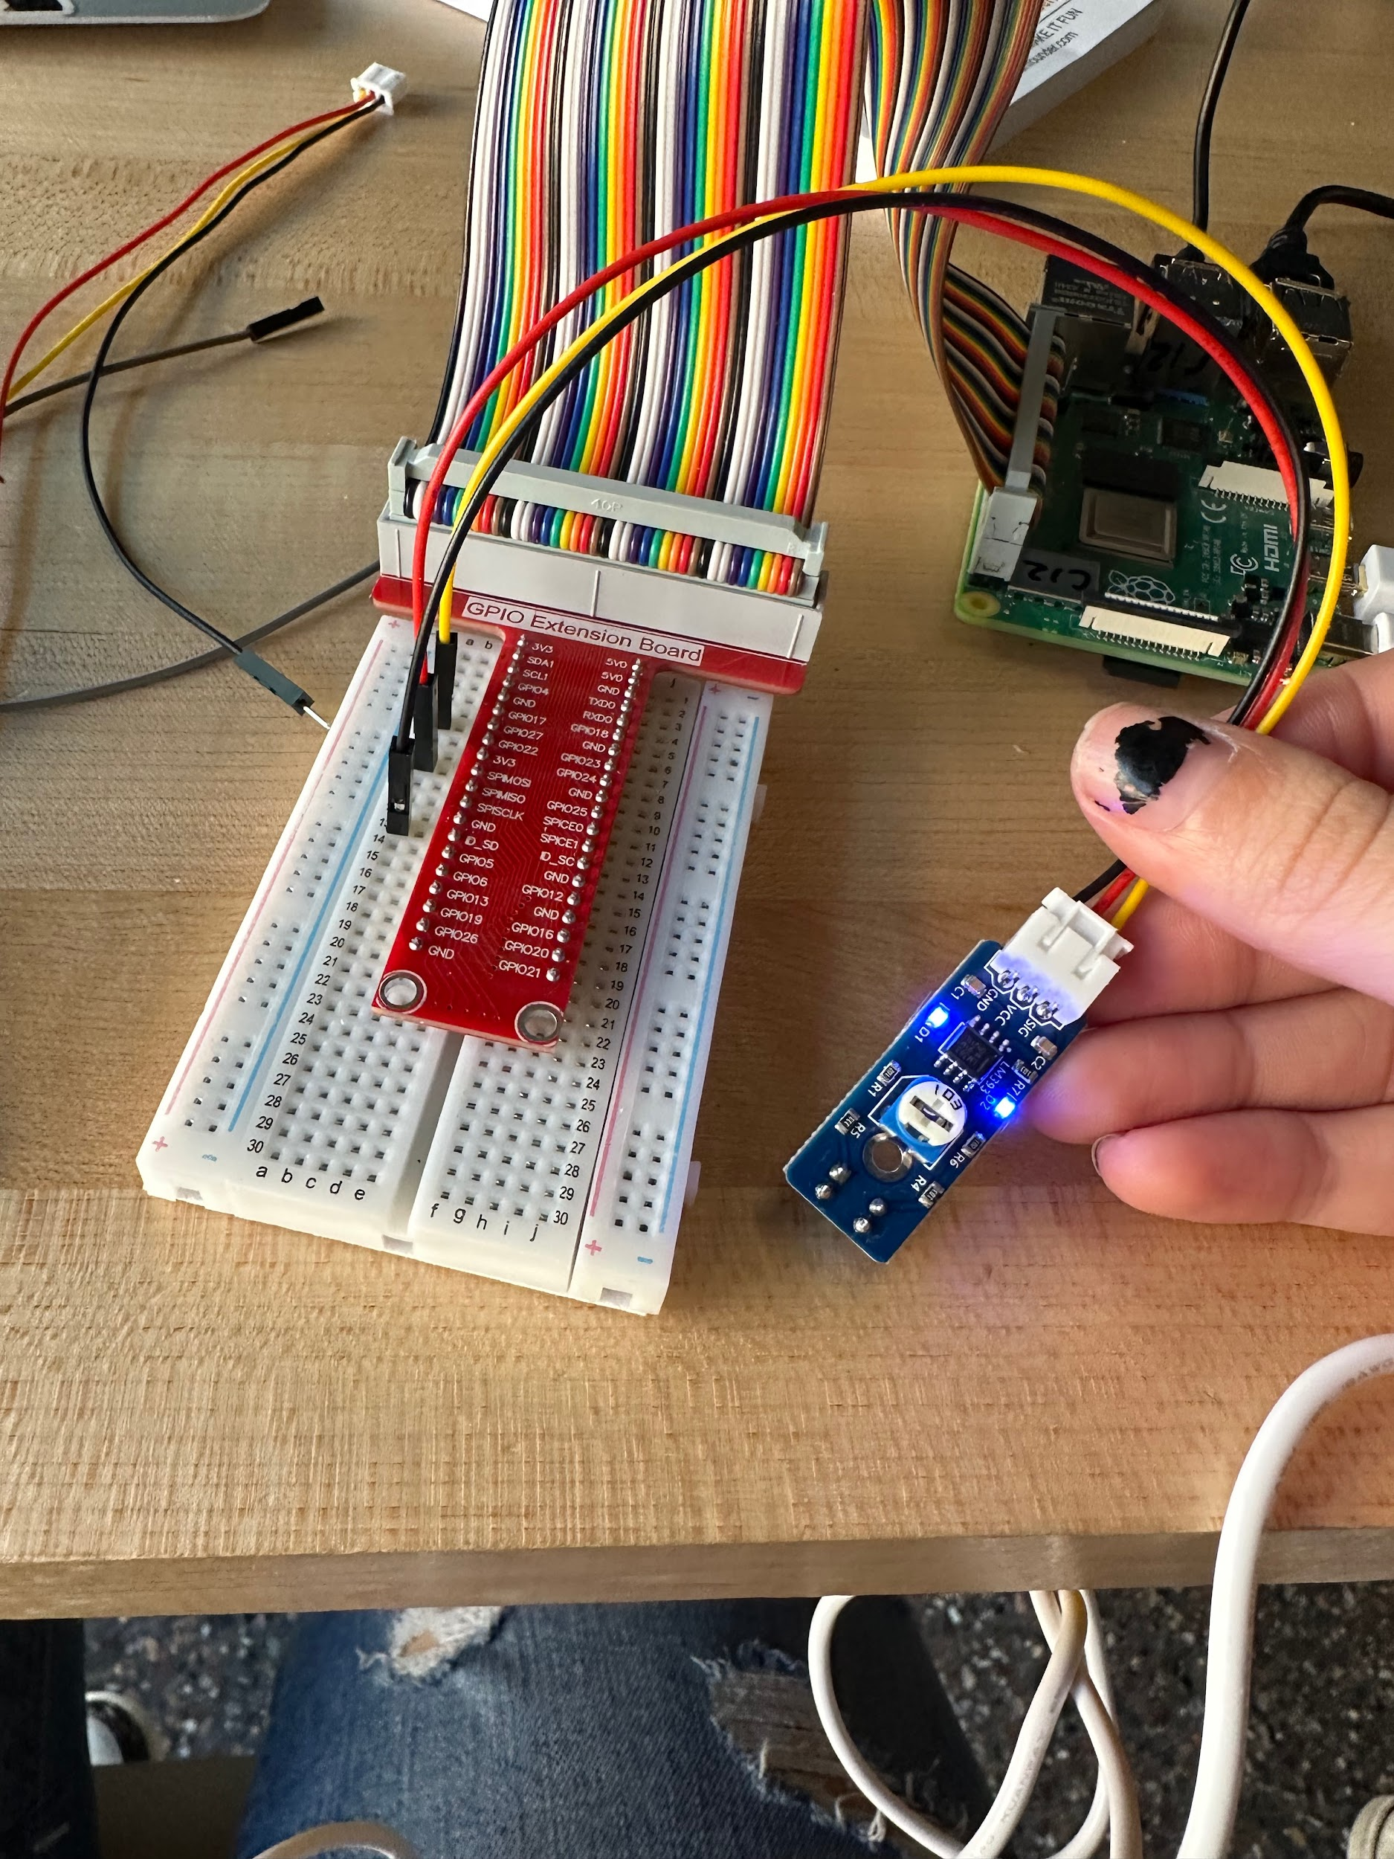

Video: <https://drive.google.com/file/d/14TiCFkI6pJnwCr0swBqL7nORh6hEcPDn/view?usp=drivesdk>

1. Color Sensor Input

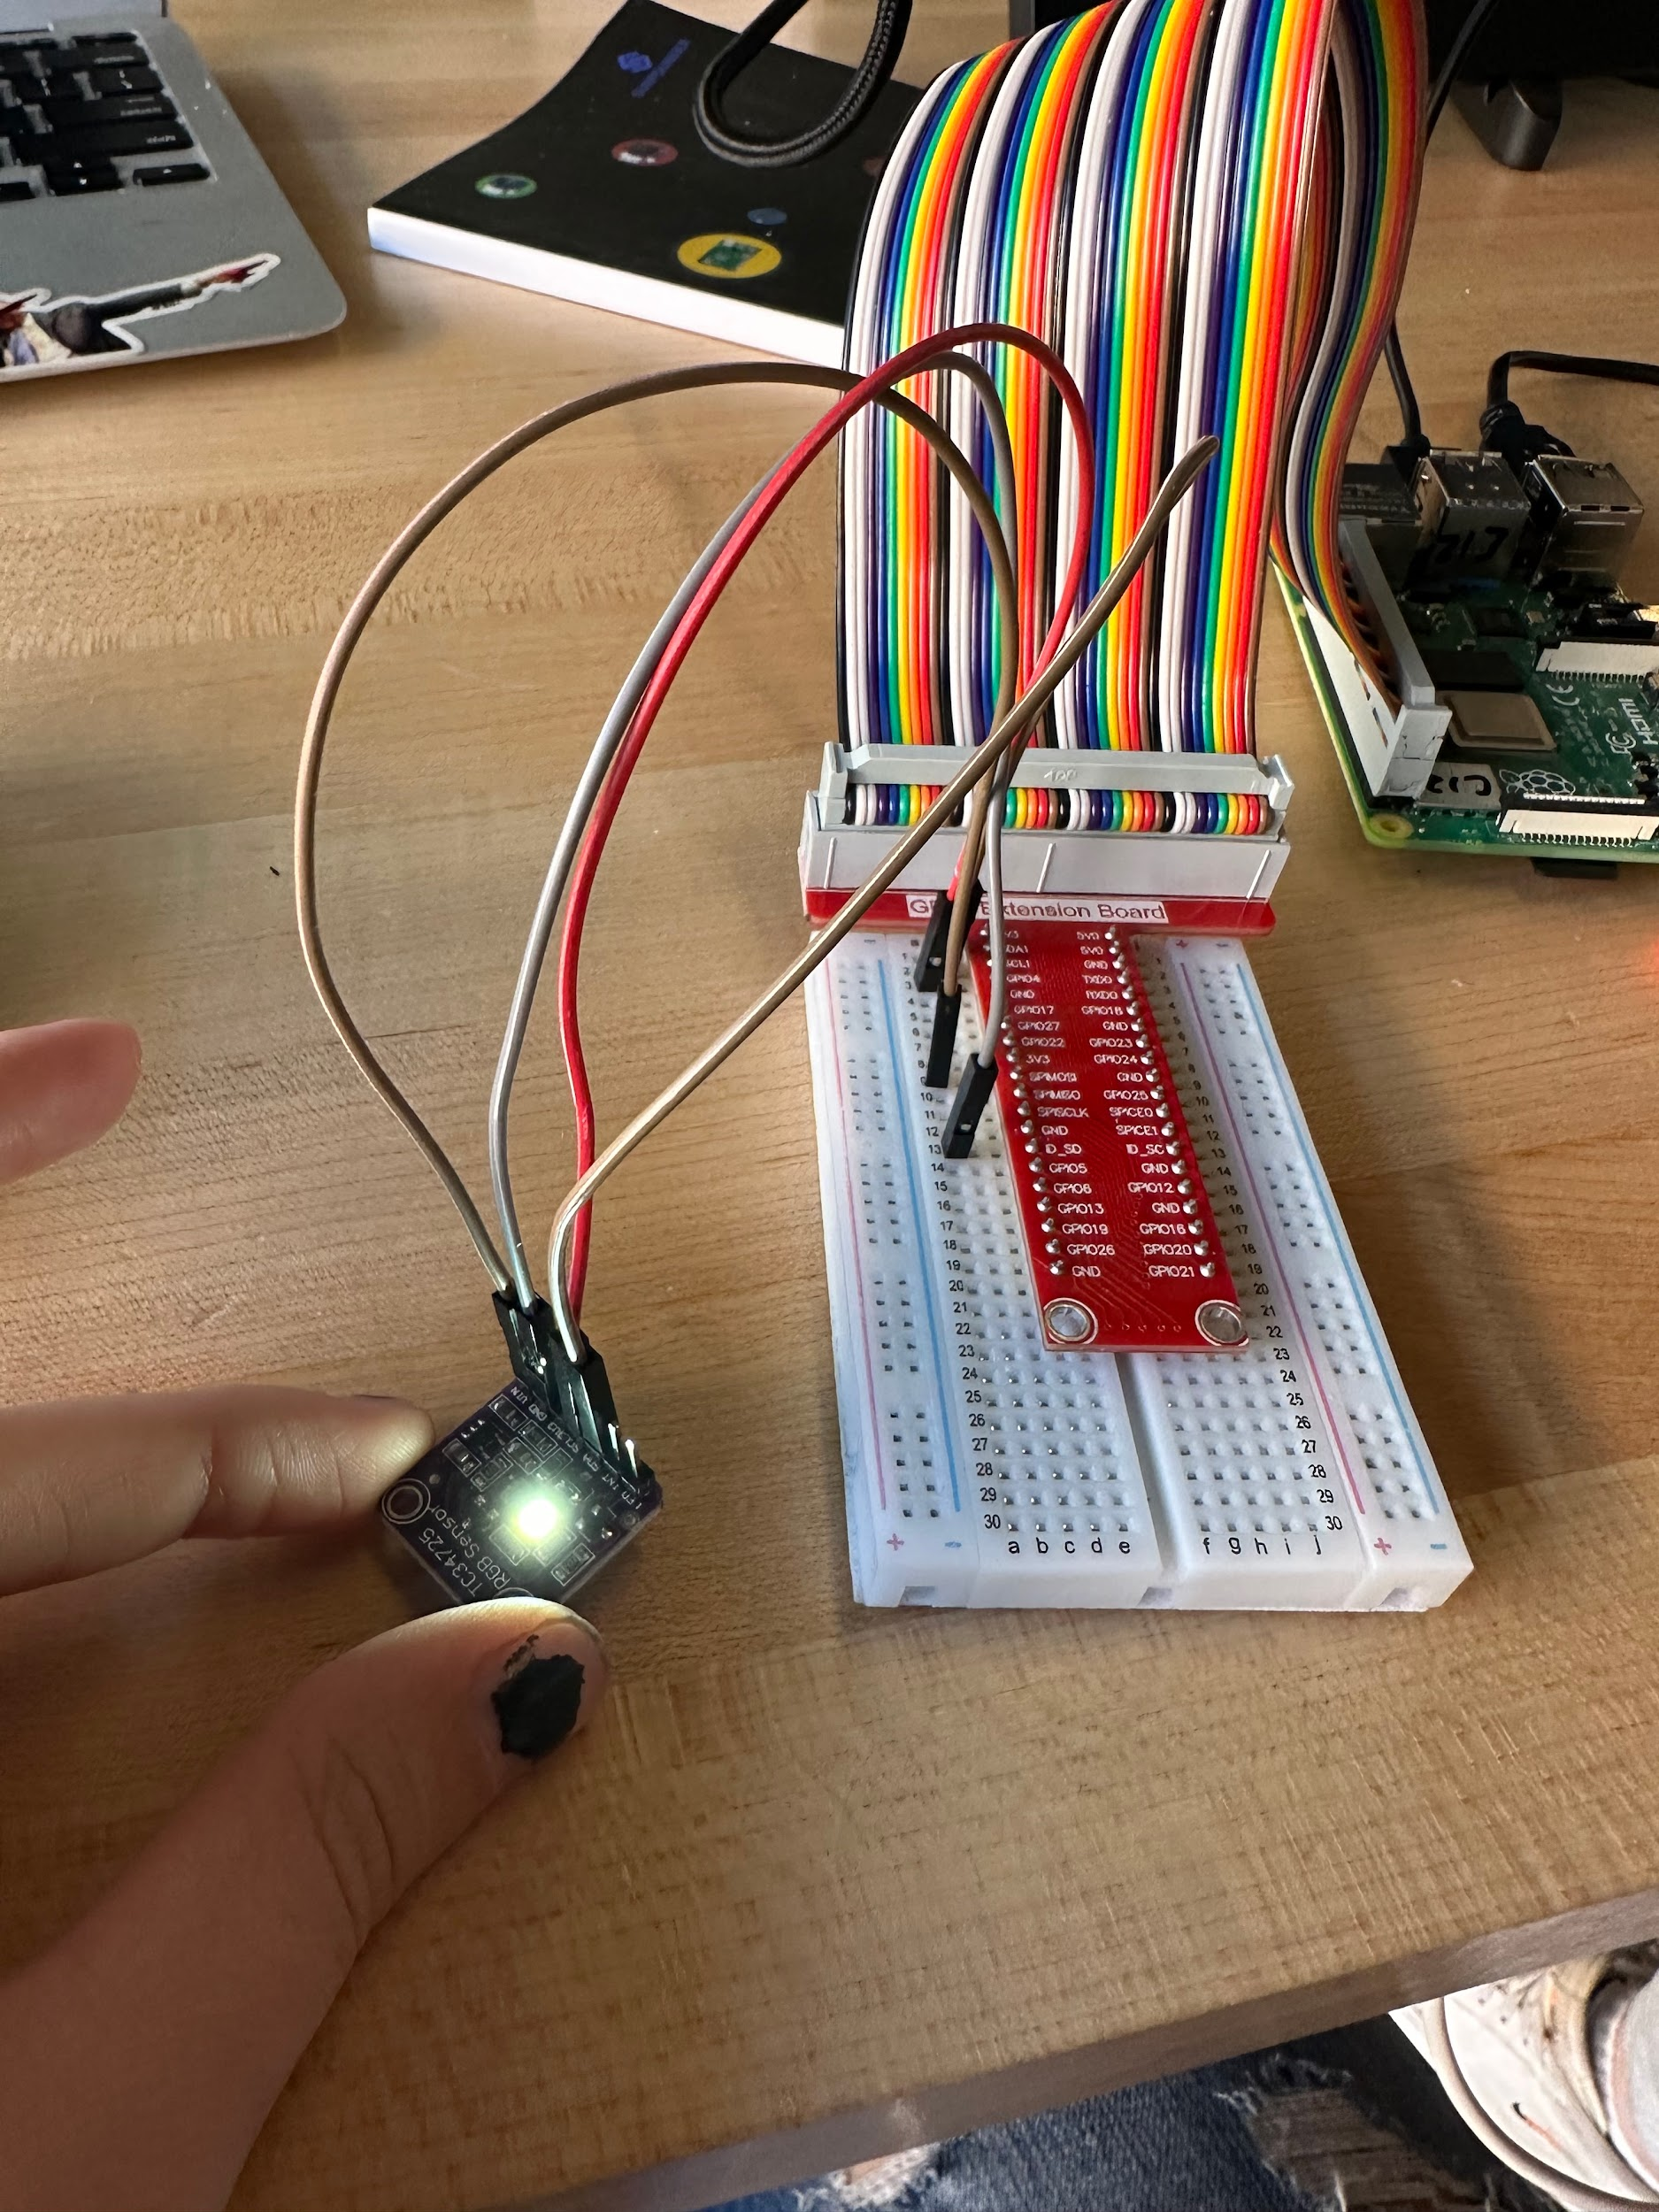

Video: <https://drive.google.com/file/d/1PkIac8v91_HDnYpMiWR7LIB6D7XwFXRc/view?usp=drivesdk>

1. Liquid Temperature Sensor

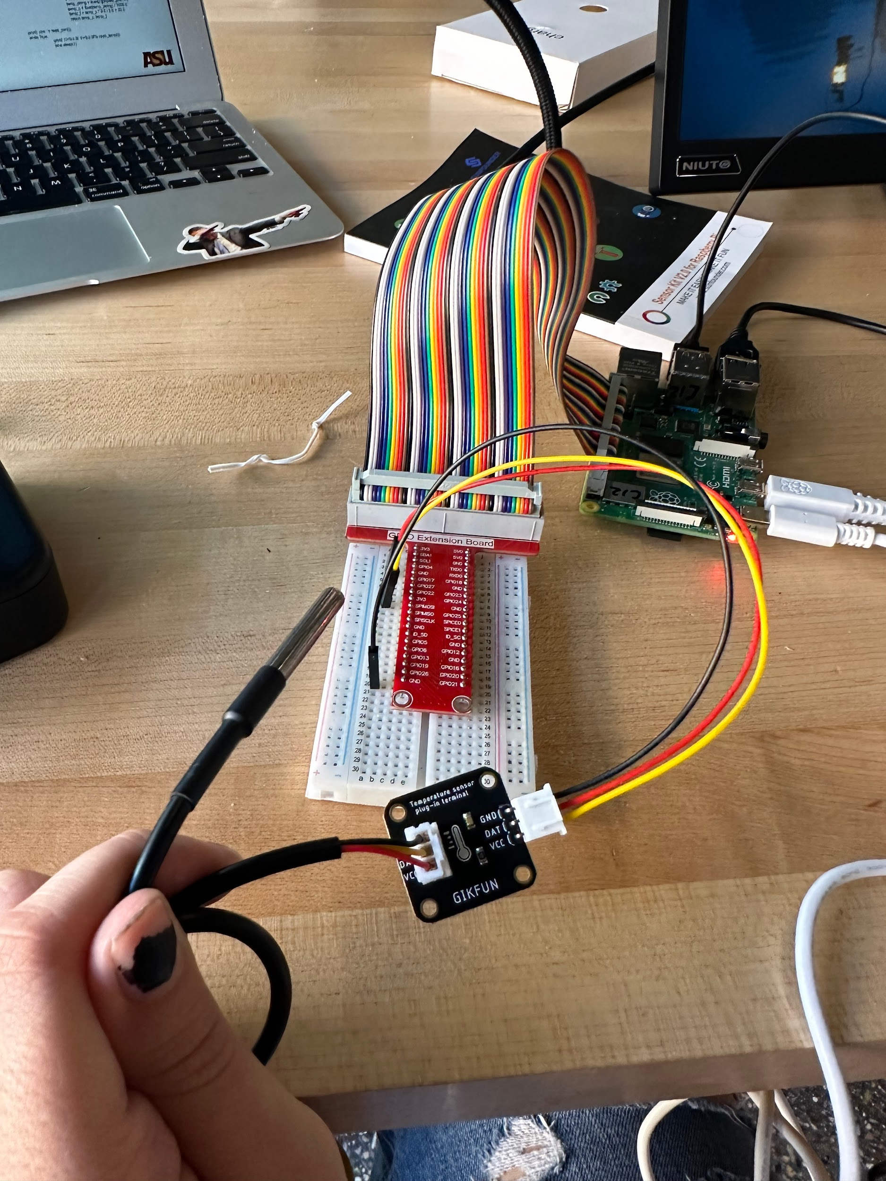

Video: <https://drive.google.com/file/d/1VZcPiFFydDfcJxDN7s4ZZuUur28dKSVD/view?usp=drivesdk>

Group MP205:

Dominic Polcyn

Ayush Pant

Thien Tran

Kaitlyn Younger